Our Ref: _______________ Your Ref: ________________________ Date: __________________

Baptist Church

Baale Yaku Site Area, P. O. Box 644,

Ogbomoso, Oyo State. Tel. 07052425407

Email: [newsprinbaptistchurch@gmail.com](mailto:newsprinbaptistchurch@gmail.com)

Website: newspringbc.comze.com

NEW SPRING

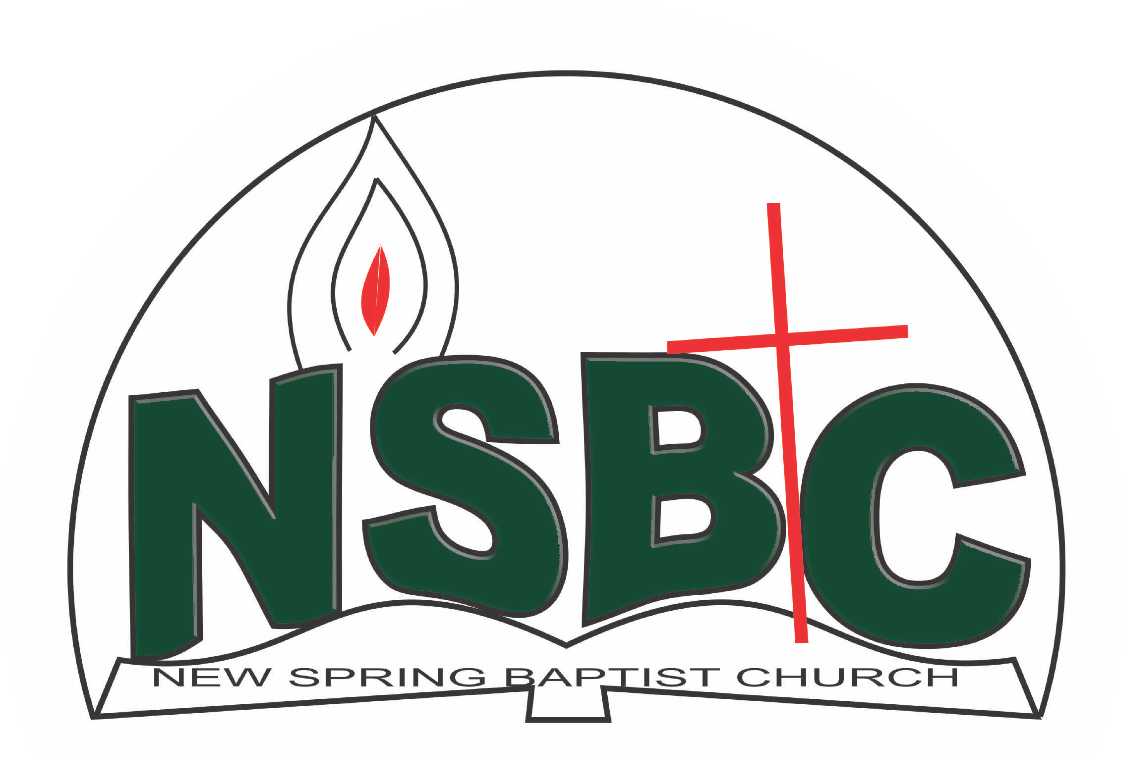

December 27, 2021

Dear Pa Adesola Adeleye,

Nomination to Serve as a Worker in the Church in 2022

Greetings in the precious name of our Lord and Saviour Jesus Christ. It is our pleasure to inform you that at the Church-in-Conference held on December 19, 2021, the Church ratified your nomination to serve in the following areas between January 1 and December 31,2022:

1. Member, Building Committee under the chairmanship of Dn. OmoOlorun Olupona
2. Member, Visitation Committee under the chairmanship of Mrs. Ruth Olanrewaju
3. Member, Church Music Committee under the chairmanship of Pastor Seun Olabode
4. Member, Church ushers under the leadership of Mr. Nathaniel Oyekunle
5. Ex-Officio, Church Council

Please refer to the table below for the key functions of each of these roles. Details can be found in the Church constitution. You are strongly encouraged to become familiar with the tasks as stated in the document. There will be an orientation of the Church workers on January 15, 2022 at 8:30 a.m. on the church premises. Please ensure you participate in this training.

“Now it is required that those who have been given a trust must prove faithful. I Corinthians 4:2”. May God find you faithful in the task He has assigned to you.

| Domain | Key function of Office, Department or Committee |
| --- | --- |
| Building Committee | Safeguard the interest of the Church in any building project the Church embarks upon |
| Visitation Committee | Visit members and worshippers at home or special institutions with a view to encouraging them in their Christian walk and reporting on pertinent issues that may require Church intervention and appropriate action |
| Music Ministry | Responsible for the music component of the Church’s worship and other programmes. |
| Church Council | The Church Council is the governing body of the Church whose membership, under the leadership of the Holy Spirit, holds one another mutually accountable with respect and love and sees to the smooth running of the Church. |
| Member, Church ushers | To provide support to the Church Pastor in guiding members and visitors to appropriate seating locations before and during service |

Thank you for accepting to serve in this Church.

Yours in His service

Olusayo Okediji Blessed Agboola

Church Secretary Chairman, Nominating Committee